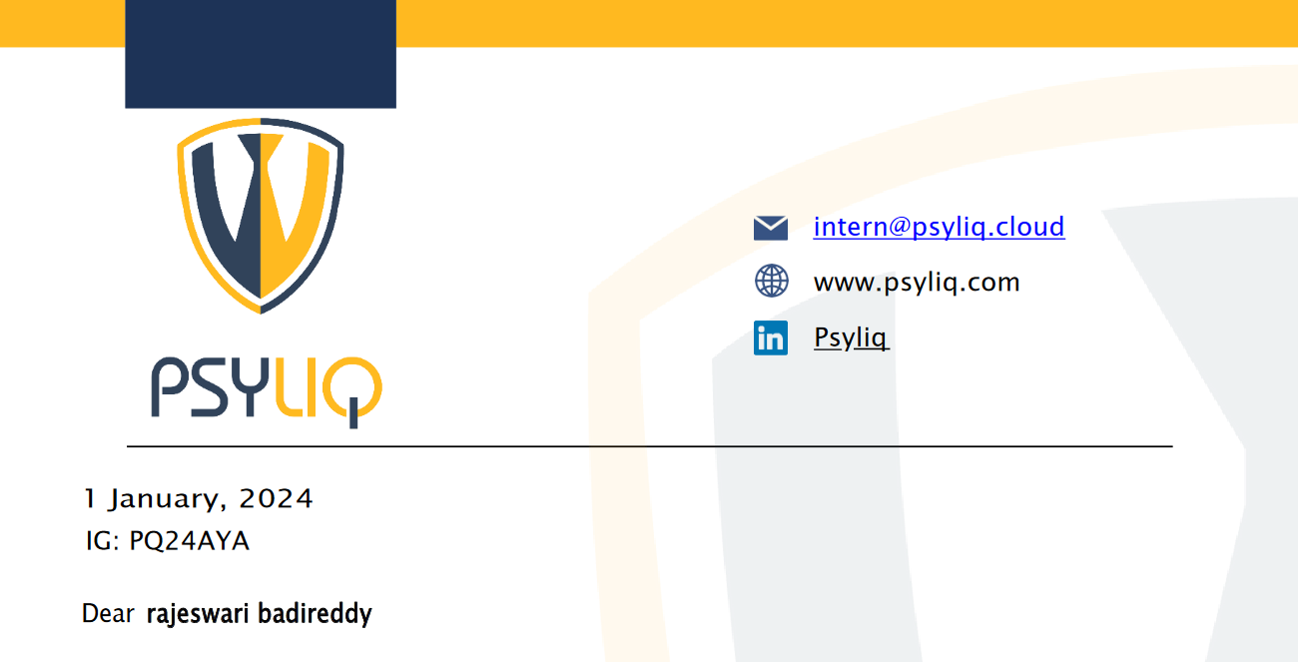



1. Using Excel, how would you filter the dataset to only show employees aged 30 and above?

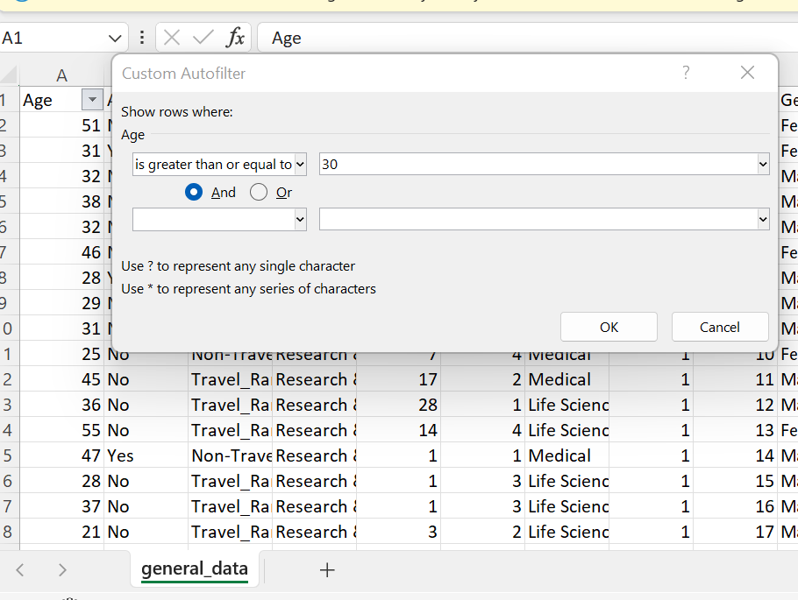

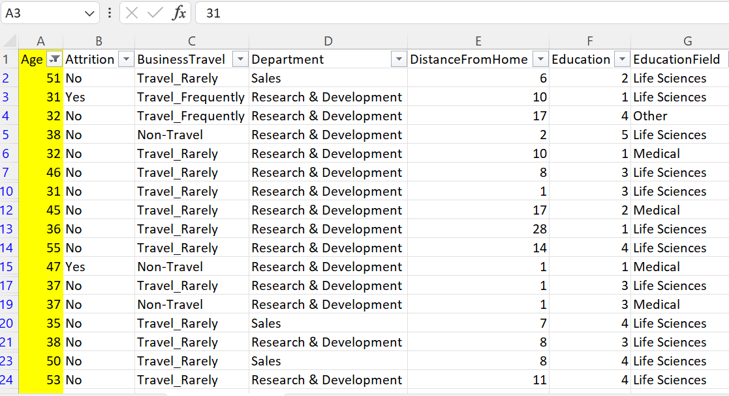

Here the given data (General_data) Age column the filter was applied – is greater than or equal to 30.

1. Create a pivot table to summarize the average Monthly Income by Job Role.

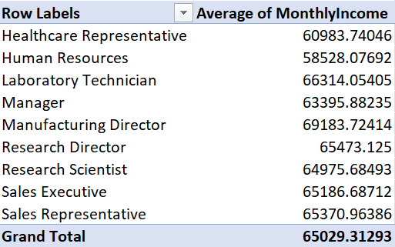

1. Apply conditional formatting to highlight employees with Monthly income above the company’s average income.

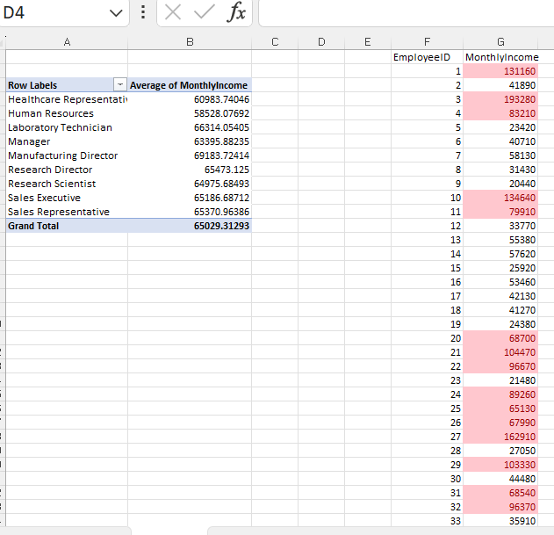

Here applied the conditional formatting to highlights the employee’s monthly average income.

1. Create a bar chart in Excel to visualize the distribution of employee ages.

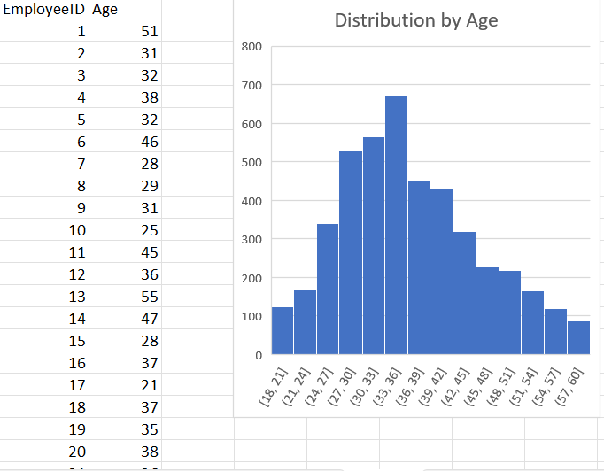

1. Identify and clean any missing or inconsistent data in the department “Column”.

Sol: - There are no missing values in our HR Data.

1. In Power BI, establish a relationship between the "EmployeeID" in the employee data and the "EmployeeID" in the time tracking data.

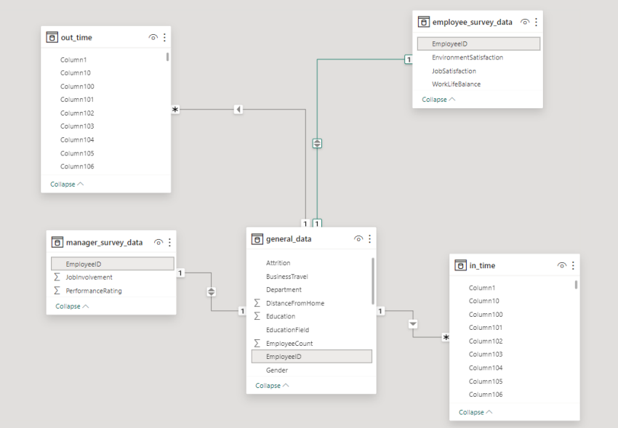

7. Using DAX, create a calculated column that calculates the average years an employee has spent with their current manager.

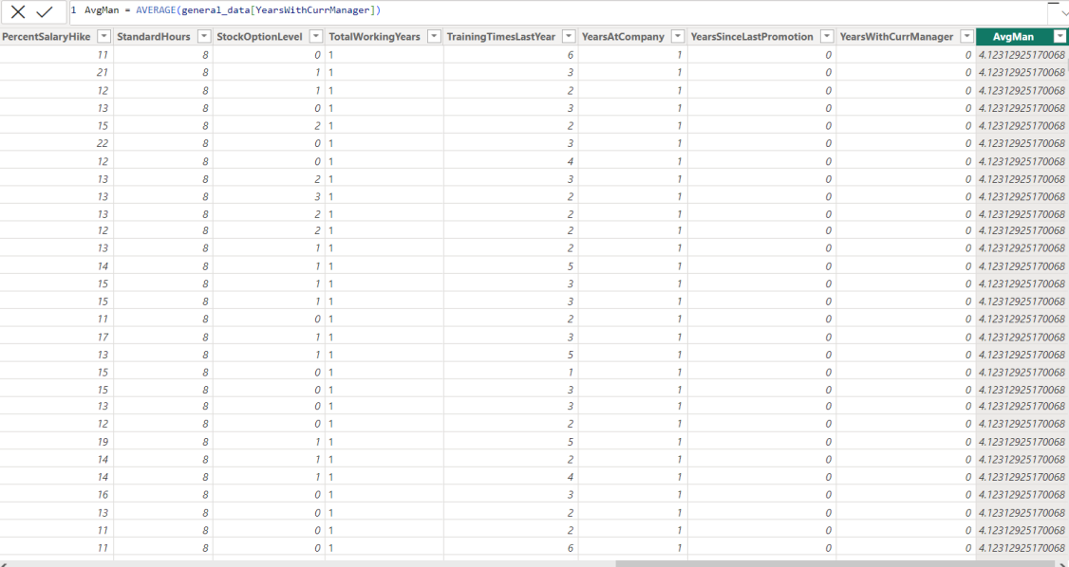

8. Using Excel, create a pivot table that displays the count of employees in each Marital Status category, segmented by Department.

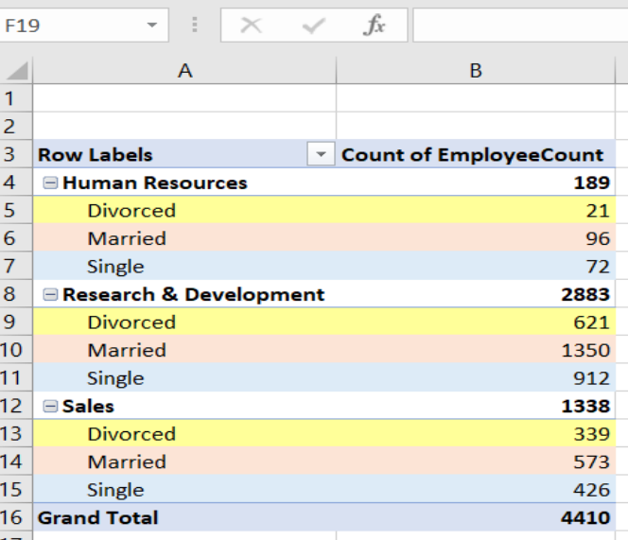

9. Apply conditional formatting to highlight employees with both above-average Monthly Income and above-average Job Satisfaction.

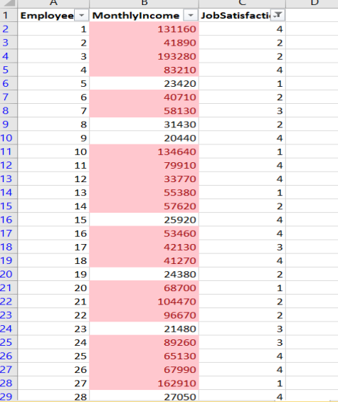

10. In Power BI, create a line chart that visualizes the trend of Employee Attrition over the years.

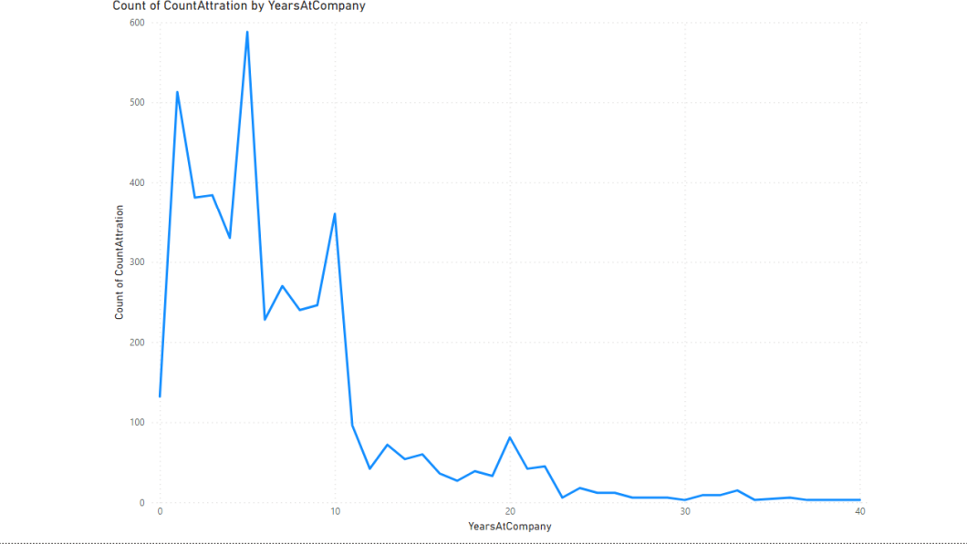  
11. Describe how you would create a star schema for this dataset, explaining the benefits of doing so.

Ans: -

A star schema organizes data into a central fact table linked to multiple dimension tables. Benefits include simplified structure, improved query performance, scalability, ease of reporting, data integrity, flexibility, and separation of concerns, making it ideal for analytical purposes.

12. Using DAX, calculate the rolling 3-month average of Monthly Income for each employee.

Rolling3MonthAvgIncome =

VAR CurrentEmployee = EmployeeIncome[EmployeeID]

VAR CurrentDate = EmployeeIncome[Date]

RETURN

CALCULATE(

AVERAGE(EmployeeIncome[Income]),

FILTER( ALL(EmployeeIncome),

EmployeeIncome[EmployeeID] = CurrentEmployee&&

EmployeeIncome[Date] <= CurrentDate &&

EmployeeIncome[Date] >= EDATE(CurrentDate, -2)

)

)

13. Create a hierarchy in Power BI that allows users to drill down from Department to Job Role to further narrow their analysis.

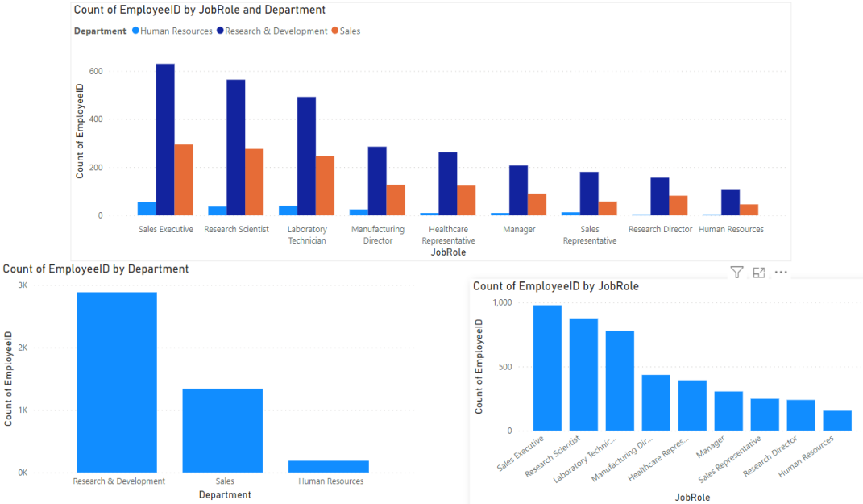

14. How can you set up parameterized queries in Power BI to allow users to filter data based on the Distance from Home column?

1. Load your data:

* Load your data into Power BI Desktop.

2. Create a table or visual:

* Create a table or visual that includesthe "Distance from Home" column.

3. Add a filter:

* Select the visual or table, and then go to the "Visualizations" pane.
* Find the "Filters" pane.
* Drag the "Distance from Home" field to the "Filters" pane.

4.Configure the filter:

* Configure the filter to be a range filter, allowing users to set a minimum and maximum distance.

5.Publish to Power BI Service:

* Save your Power BI Desktop file and publish it to the Power BI service.

6.Share the dashboard:

* Share the dashboard with your users.

15. In Excel, calculate the total Monthly Income for each Department, considering only the employees with a Job Level greater than or equal to 3.

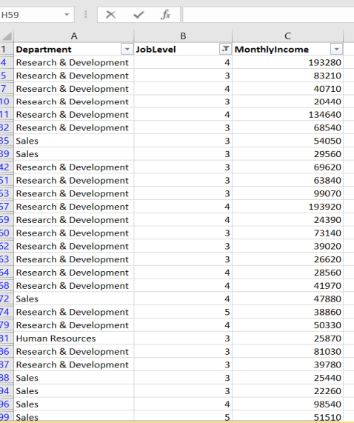

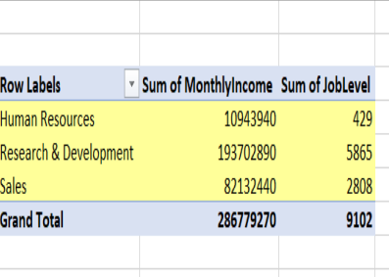

16. Explain how to perform a What-If analysis in Excel to understand the impact of a 10% increase in Percent Salary Hike on Monthly Income.

Ans: -

To perform a What-If analysis in Excel for a 10% increase in Percent Salary Hike on Monthly Income:

1. Data Table Method: -

* Create a table with "Percent Salary Hike" and "Monthly Income" columns.
* Use the Data Table feature under "What-If Analysis" in the "Data" tab.

1. Goal Seek Method: -

* Set initial values, including the 10% increase in a cell.
* Use the Goal Seek feature under "What-If Analysis" to find the required percentage for the desired Monthly Income.

17. Verify if the data adheres to a predefined schema. What actions would you take if you find inconsistencies?

Ans: -

To verify data adherence to a predefined schema:

1. Review Schema:

* Understand the expected structure, data types, and constraints.

1. Use Tools and Queries:-

- Utilize data profiling tools, SQL queries, and scripts to validate data against the schema.

3. Automate Testing:

- Implement automated tests for ongoing schema adherence.

4. Collaborate with Stakeholders:

- Engage with stakeholders to understand changes and ensure the schema reflects current needs.

5. Address Inconsistencies:

- Use data cleaning, transformation, and governance practices to address inconsistencies.

6. Continuous Monitoring and Improvement:

- Establish continuous monitoring, gather feedback, and iteratively improve data management practices.

